Name_________________________________________________________Date______________Hour_______
Animal Adaptations: Bird Beak Lab
Description: This is an activity designed to provide a hands-on activity to help you explore animal adaptations, namely the shape of a bird's beak in relation to their food source.
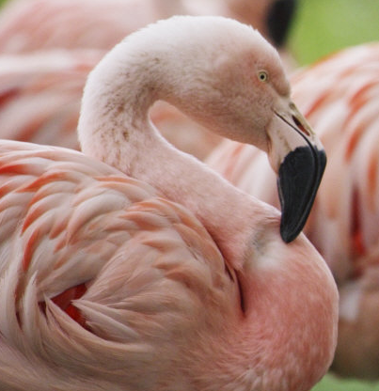
Objectives: Students will:
1.) Understand bird adaptation on type of food supply.
2.) Deduce what beaks are most efficient for obtaining given foods by experimenting with
imitation beaks and given food sources.
3.) Describe what will happen to a bird population if its environment can no longer support the
bird's food source.

Bird Identification Guide
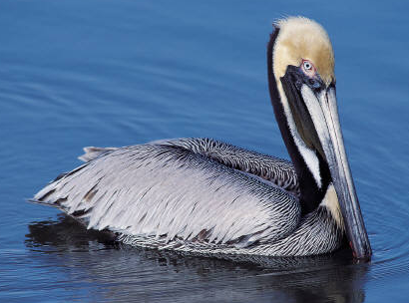
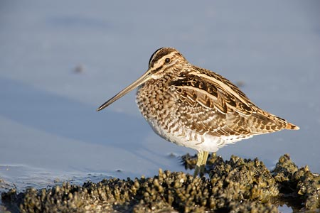
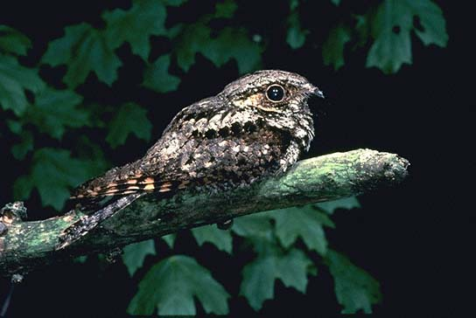
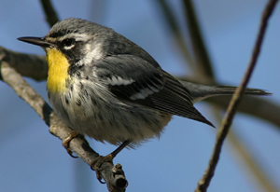
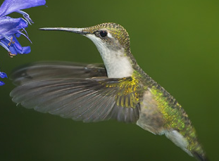
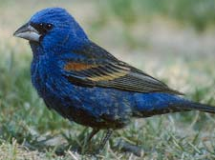
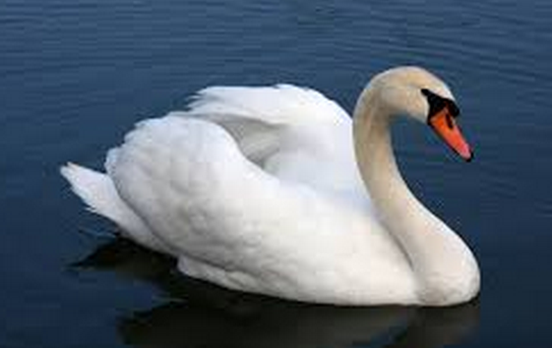

Whip-poor-will Snipe Pelican Swan Hummingbird Warbler Grosbeak

Predictions: Look at the pictures above and the tool that represents each bird and predict which type of food each bird will eat. Matching the bird on the left with its food on the right.
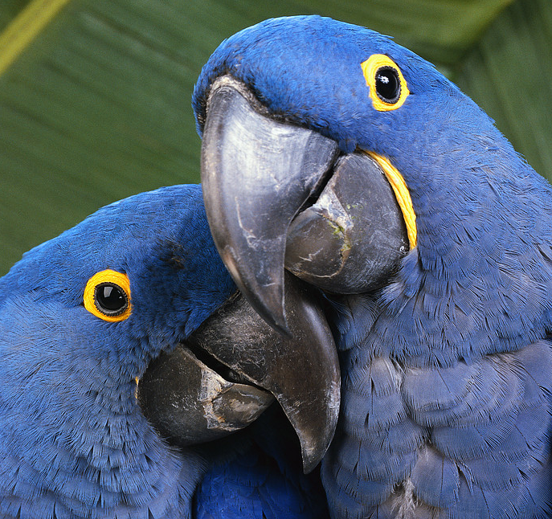
_____Whip-poor-will (Tweezers) A. Nectar
_____Snipe (Chopsticks) B. Worms
_____Pelican (Strainer) C. Seeds
_____Swan (Clothespin) D. Fish and other water animals
_____Hummingbird (Eyedropper) E. Tiny water plants
_____Warbler (Envelope) F. Flying Insects
_____Grosbeak (Pliers) G. Small insects

Background: Each lab station represents a different habitat where birds gather their food. The tools at each station (“habitat”) represent 3 different types of bird beaks. Your group will move to each habitat to test which type of bird beak best fits with the habitat food. DO NOT put any tool in your mouth or eat anything at the station!

Procedure:
- Follow the directions on the challenge card at your station and record your data in the data table.
- Before leaving the station, return all materials to their original places.
- When the teacher tells you switch to the next station and repeat steps 1 and 2.

Data Table
Station # | Average Time Tool #1 | Average Time Tool #2 | Average Time Tool #3
1 - Nectar | Chopstick | Eyedropper | Spoon
2 - Worms | Chopstick | Envelope | Spoon
3 – Seeds | Chopstick | Pliers | Spoon
4 – Small Fish | Chopstick | Strainer | Spoon
5 – Water Plants | Chopstick | Clothespin | Spoon
6 – Flying Insects | Chopstick | Envelope | Spoon
7 – Small Insects | Eyedropper | Envelope | Tweezer

STATION QUESTIONS

STATION 1
Which type of bird beak fits best with the nectar (water) found in this habitat? Why?

STATION 2
Which type of bird beak fits best with the worms found in this habitat? Why?

STATION 3
Which type of bird beak fits best with the seeds (peanuts) found in this habitat? Why?

STATION 4
Which type of bird beak fits best with the tiny fish (ribbon) found in this habitat? Why?

STATION 5
Which type of bird beak fits best with the water plants (leaves) found in this habitat? Why?

STATION 6
Which type of bird beak fits best with the flying insects (cotton balls) found in this habitat? Why?

STATION 7
Which type of bird beak fits best with the small insects (rice) found in this habitat? Why?

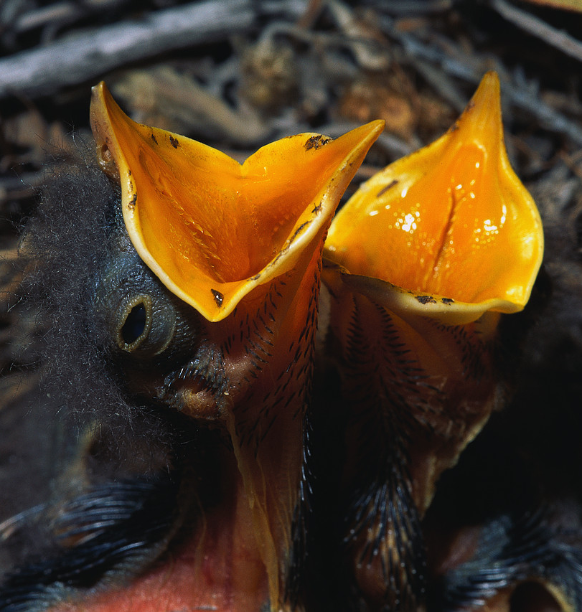
Analysis:
- Now that you’ve completed the lab, matching the bird on the left with its food on the right.

_____Whip-poor-will (Tweezers) A. Nectar
_____Snipe (Chopsticks) B. Worms
_____Pelican (Strainer) C. Seeds
_____Swan (Clothespin) D. Fish and other water animals
_____Hummingbird (Eyedropper) E. Tiny water plants
_____Warbler (Envelope) F. Flying Insects
_____Grosbeak (Pliers) G. Small insects

Use complete sentences.
- After doing this lab explain why all birds do not have the same beak?

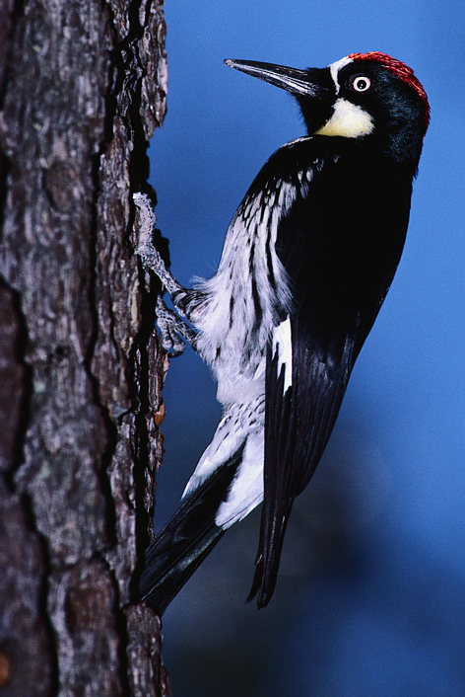
- What might happen to the hummingbirds if the nectar no longer grew in their habitat? Explain why.

- What birds would be negatively affected if a farmer used an insecticide that killed off all of the insects?

- Based on the information you have gathered, describe what a beak that can effectively pick up and crack small seeds might look like.

- Think of three other organisms (not birds). For each, describe an adaptation that has helped that organism survive in its environment.

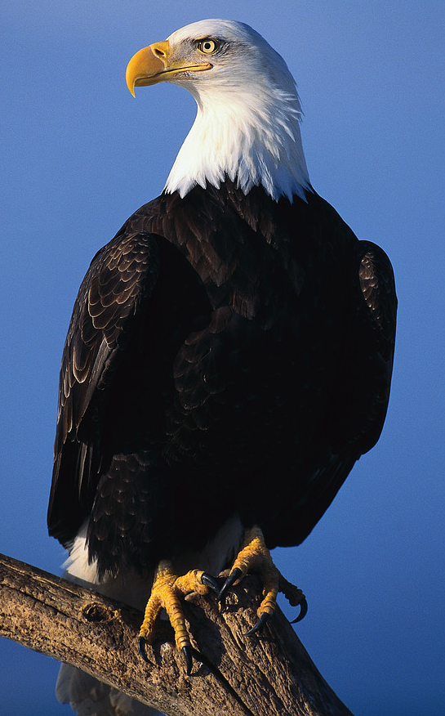

- What is an adaptation? Why are adaptations important to life on earth?

Fill the Bill
Directions: Under each picture, write the correct beak adaptation by comparing the drawing to the bill descriptions.

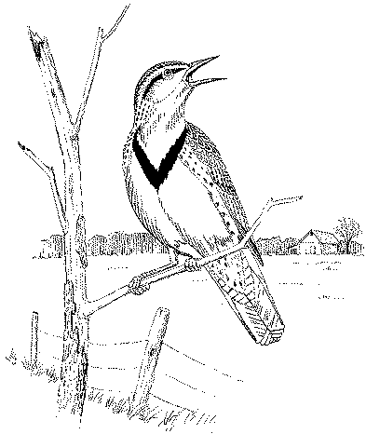
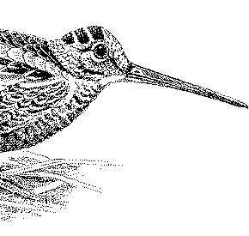  Woodcock | Meadowlark | 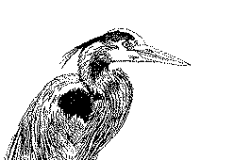  Great Blue Heron
1) 2) 3)

Bald Eagle  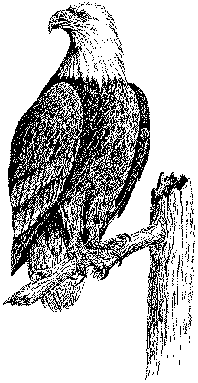 | Wood Duck  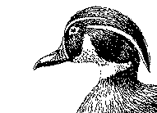 | 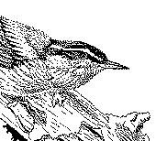 Nuthatch
4) 5) 6)

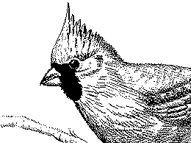  Cardinal | 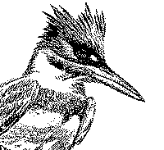  Kingfisher | 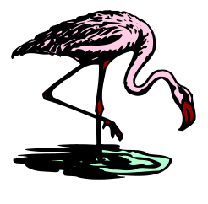  Flamingo
7) 8) 9)

BEAK ADAPTATIONS

Fish-eating beak: long, slim, strong, and pointed to reach into the water and to grasp slippery creatures.

Insect-catching beak: small sized beak that can open wide to grab insects in flight.

Water and Mud-sifting beak: wide and shallow; comb-like strainers on edges filter out bits of food in water.

Chisel beak: sturdy and sharply pointed to chisel into wood; accompanied by an extremely long, barb-tipped tongue to pull insects and insect eggs out of tunnels in bark or wood.

Insect and Fruit-eating beak: narrow and pointed to grab insects or reach fruits, and slightly arched to crack seeds; larger than an insect-eating beak but shorter than a fish-eating beak; sleeker and longer than a seed-eating beak.

Preying beak: stout, sharp and sharply hooked to tear the flesh of animals.

Probing beak: thin and long to reach insects and other small animals buried in sand or mud.

Filter beak: large and curved with grooves and comb-like filter for sifting out crustaceans from water.

Seed Eating beak: short and thick, able to crack open seeds.

