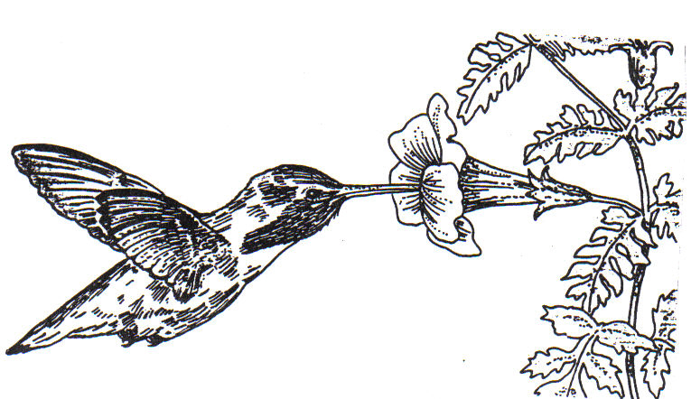

Humming bird feed on nectar from
flowers.

WHAT’S THE TYPE OF SYMBIOSIS ?

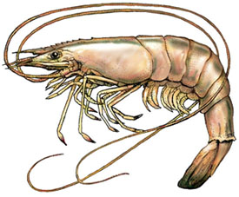

SNAPPING SHRIMP have poor
vision and depend on their goby fish
roommate to give the danger signal
when predators come and guide them
back home if they wander too far.

WHAT’S THE TYPE OF SYMBIOSIS ?

Flowers are pollinated by hummingbirds as they move from flower to flower.

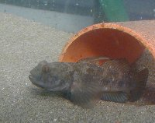

GOBY FISH who don't have a place to hide are quickly eaten. They find a Snapping shrimp roommate who digs a hole for
both to live in.

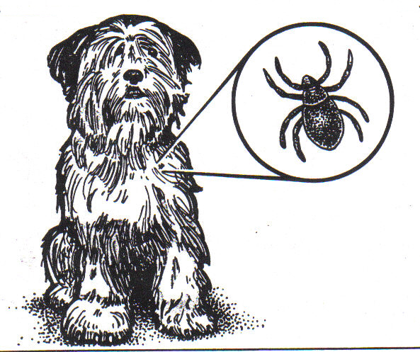

Tick lives on dog and feeds on its
blood and tissue.

WHAT’S THE TYPE OF SYMBIOSIS ?

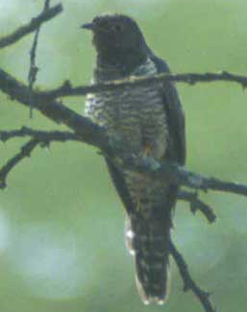

Red-chested cuckoo birds find an unattended robin nest, push out the
robin eggs, and lay their eggs in the
robin’s nest, and leave.

WHAT’S THE TYPE OF SYMBIOSIS ?

Dog gets skin irritation and can pick up diseases carried by tick.

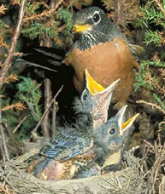

Robin babies die and robin parents feed
and take care of the cuckoo babies.

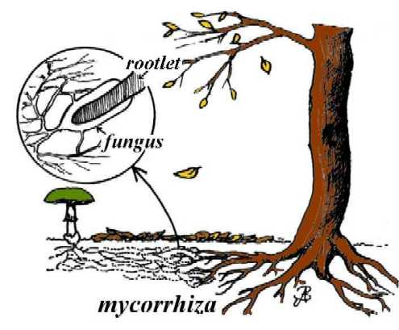

Mycorrhizal fungi invade and live in or among roots cells of many plants.
The plant provides nutrients to the fungi.

WHAT’S THE TYPE OF SYMBIOSIS ?

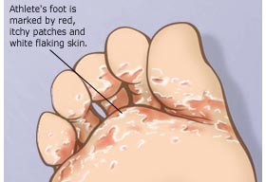

Athlete’s Foot fungus lives on the skin of
humans and feeds on keratin, a protein.

WHAT’S THE TYPE OF SYMBIOSIS ?

The Mycorrhizal fungi help the host plant absorb inorganic nitrogen and phosphorus from the soil. Some mycorrhizal
fungi also secrete antibiotics which may help protect their host from invasion by parasitic fungi and bacteria.

Humans have itchy, cracked skin which
can become infected.

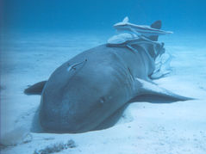

REMORA use suckers to attach temporarily
to large marine animals such as sharks, manta rays, whales, turtles, or large fish.

WHAT’S THE TYPE OF SYMBIOSIS ?

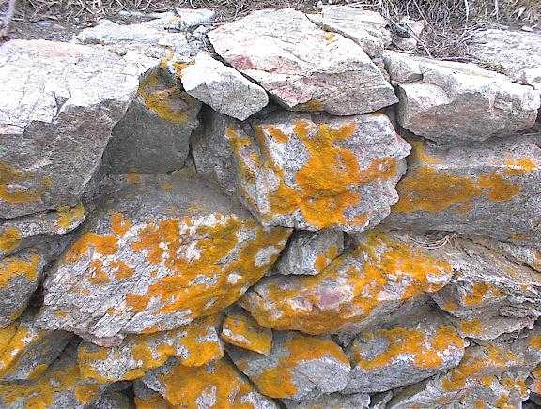

.

FUNGI form lichens by living in a close relationship with an algae. The fungus provides a protective home for the algae,
and gathers mineral nutrients from rainwater and from dissolving the rock underneath

WHAT’S THE TYPE OF SYMBIOSIS ?

The SHARK provides free transportation,
protection, and dropped food and feces which the remora feeds on. The host is not injured.

The ALGAE gathers energy from the sun using photosynthesis. Both organisms share their nutrients with each other

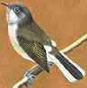

Honeyguide birds find a bee hive, then chatter loudly to attract the Honey badger. They fly toward the hive
making sure the badger is following.

WHAT’S THE TYPE OF SYMBIOSIS ?

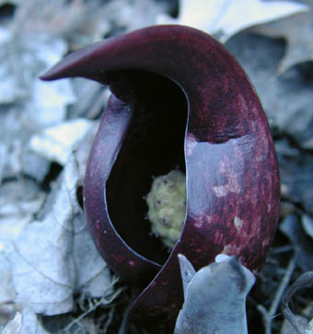

SKUNKCABBAGE plants attract flies in cool weather by making heat and provide
food to the flies that come.

WHAT’S THE TYPE OF SYMBIOSIS ?
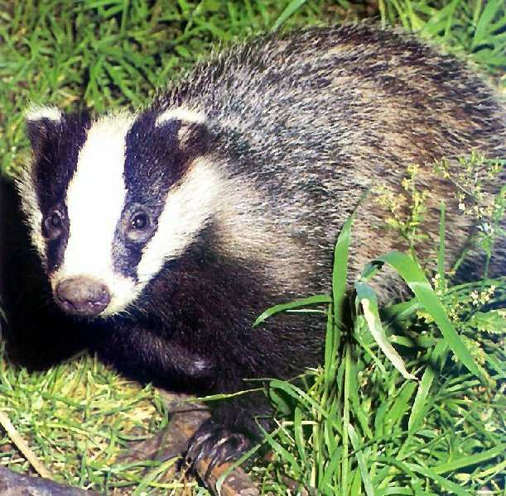

Upon arrival at the bee hive, the badger tears open the hive and feasts
on the honey. Then the Honeyguide bird feeds on the remaining wax and larvae.

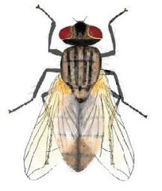

FLIES move from one Skunkcabbage plant to the next feeding and
transferring pollen as they go.

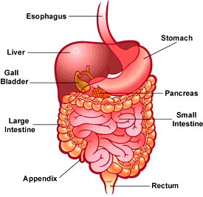

HUMAN intestine provides food for bacteria that live inside digestive system

WHAT’S THE TYPE OF SYMBIOSIS ?

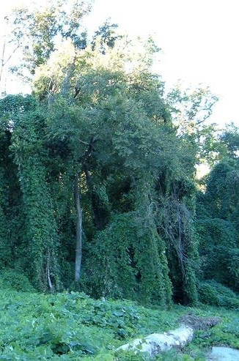

Kudzu vines grow by climbing, and wrapping around trees.

WHAT’S THE TYPE OF SYMBIOSIS ?

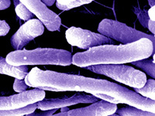

Beneficial BACTERIA live in the intestine of humans and help digest cellulose from
plants which humans don’t have the enzymes to break down.

KUDZU COVERED TREES die as they are smothered and break under the weight of the growing Kudzu vines

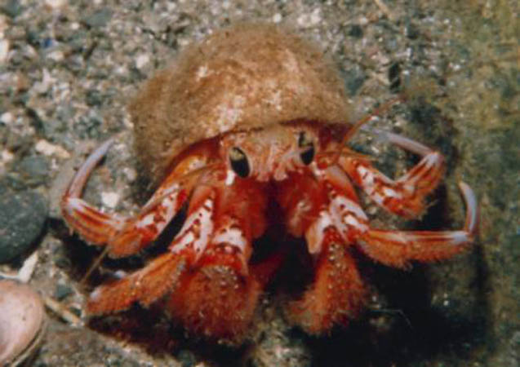

Hermit crabs find shells left by
Snails that have died and move in.

WHAT’S THE TYPE OF SYMBIOSIS ?

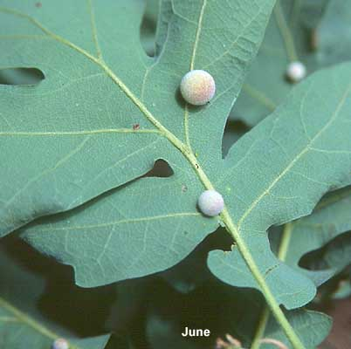

GALL INSECT lays their eggs in the leaves or branches of Oak trees causing a
lump to form.

WHAT’S THE TYPE OF SYMBIOSIS ?

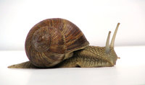

Snails die and leave behind their shells.

OAK TREES provide shelter and food to the insect larvae, but are not harmed.

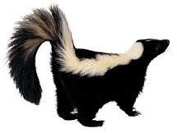

Skunks often live in burrows that have
been dug and abandoned by woodchucks.

WHAT’S THE TYPE OF SYMBIOSIS ?

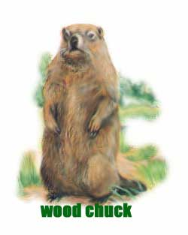

Woodchucks abandon holes which
are later used by skunks

